Friends of Wisconsin Trout Unlimited Grant Application
- Fill in the name of the chapter requesting the Friends grant. Only Wisconsin Trout Unlimited chapters are eligible for Friends grants.
Chapter of Trout Unlimited

- Friends grants are only awarded for habitat projects on property on which public access to the stream corridor has been guaranteed in perpetuity. State what kind of public access is in place for the area on which you are requesting Friends funds: Examples could be: TU Easement, DNR Easement, State Ownership, County Easement, County Ownership, National Ownership, or Local Municipality Ownership.
Answer

- Friends funds may only be used for cold water habitat improvement projects. Describe the project for which you are requesting grant funding. Your description should include; a detailed description of the project location, the type of work to be performed, partners involved in the project, all funding sources for the project, the total cost of the project, and the expected outcome of the project.
- Detailed description of the project:
Describe project
- Location of the project:
Location
- The type of habitat work to be performed:
Describe habitat work

- Partners involved in the project:
List Partners

- Total project cost and all funding sources:
Total Project Cost:
Sources of Funding:

- Expected outcome of the project:
Describe goals

- State the dollar amount you are requesting. Note that an individual chapter may receive a maximum amount of $2000 annually.
$0,000

- The Friends program includes a match obligation for requesting chapters. The match amount is equal to 100% of the granted amount. Matches may be made by cash, labor calculated at the prevailing federal labor rate, or in kind contributions. Explain the chapter plans to meet the match requirement.
Answer

- Date on which you are submitting this application. Grants are awarded once per year. Requests must be received by January 15 to be considered the February Annual Meeting.
Submitted on DATE
By:
Contact Info:
Your completed application should be submitted to the current State Council Chair either online or through the mail. The State Council Chair will then submit the application to the State Council Vice Chair and the State Council Regional Vice Chairs who make final decisions on awarding grants.
For criteria used in deciding whether or not to approve a grant please consult a copy of the Friends Language which is available from the State Council Chair if you do not currently have a copy.
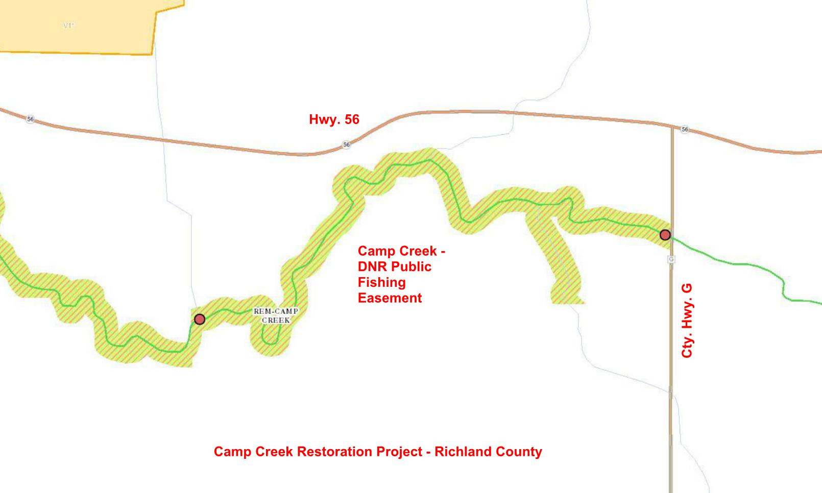
Sample Location Map – (right click picture and select “change picture” to load your own), then update this caption
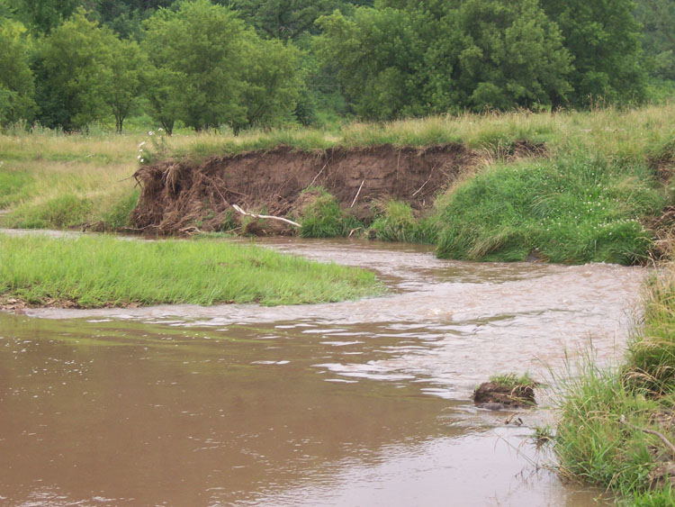
Sample Image – (right click picture and select “change picture” to load your own) then update this caption

