***Wisconsin Conservation Hall of Fame 2018 News***

***Roy and Charlotte Lukes, George Meyer, and Arlie Schorger to be Inducted on Saturday, April 14th***

***Public is Invited***

**Saturday, April 14, 2018**

**Sentry Theater in Stevens Point**

**Program:** 9:00 Coffee reception (free)

10:00 Induction Ceremony (free)

12:30 Luncheon – ($25/person)



Reservations may be made on Eventbrite [http://bit.ly/WCHF2018Registration](https://urldefense.proofpoint.com/v2/url?u=http-3A__bit.ly_WCHF2018Registration&d=DwMFAg&c=-cNKEo6N5UU7B9VDGD_3Mw&r=zdWMWtdjearADaw_6UW6mYxqiAxdkw6Onig3xjcdHxQ&m=TRyItYGdrncwMvUn-eu9smnaWRSt7MS-1TccnldaViU&s=cfInm3vLGuyIEyEyUqbDwJvTIzBFoVzGhTKZ1vUxL_s&e=) or call Schmeeckle Reserve: 715-346-4992.

See Full News Release on WCHF Website [http://bit.ly/WCHF2018Inductees](https://urldefense.proofpoint.com/v2/url?u=http-3A__bit.ly_WCHF2018Inductees&d=DwMFAg&c=-cNKEo6N5UU7B9VDGD_3Mw&r=zdWMWtdjearADaw_6UW6mYxqiAxdkw6Onig3xjcdHxQ&m=TRyItYGdrncwMvUn-eu9smnaWRSt7MS-1TccnldaViU&s=jL1tQZ_WQrM4UUYrQp1YXG_wtlR2CZQglpr_AcY1o8U&e=)

or at direct url: [http://bit.ly/WCHF2018NewsRelease](https://urldefense.proofpoint.com/v2/url?u=http-3A__bit.ly_WCHF2018NewsRelease&d=DwMFAg&c=-cNKEo6N5UU7B9VDGD_3Mw&r=zdWMWtdjearADaw_6UW6mYxqiAxdkw6Onig3xjcdHxQ&m=TRyItYGdrncwMvUn-eu9smnaWRSt7MS-1TccnldaViU&s=Tb1_V_5G0ZxXn_P8bpuM5qD8-ckrf_Wv_fl9kBVgGNM&e=)

**_________________________________**

**NEWS RELEASE (1) *Feb 1, 2018***

**Contacts:**

1. Joe Passineau, WCHF President

Email: jpassine@uwsp.edu

Phone: 715-677-4047

**Notes:**

1. This release could be shortened for an informational brief or used, as is, for a longer feature story (published prior to the event or after its completion).

2. For Digital Copy and Photos contact: Joe Passineau at [jpassine@uwsp.edu](mailto:jpassine@uwsp.edu). Please show photo credits.

_________________________________________

***Wisconsin Conservation Hall of Fame – 2018 News***

The Wisconsin Conservation Hall of Fame (WCHF) will honor four new leaders who have contributed much to Wisconsin’s Conservation Legacy. This year’s ceremony will begin at 10 a.m. on Saturday April 14th at the Sentry Theater in Stevens Point. The public is invited.

The Inductees this year include: (1) a couple who have spent their lives as “Partners in Nature” protecting the natural heritage of Door County, (2) a Secretary of the Wisconsin Department of Natural Resources who never retired, and (3) an almost forgotten UW-Madison Wildlife Professor and philanthropist who contributed directly to Leopold’s Conservation Legacy.

**Induction Ceremony Details**

The Induction Ceremony will be held at 10 a.m. Saturday, April 14, at Sentry Theater in Stevens Point. A coffee reception at 9 a.m. will precede the Ceremony. The Luncheon is at 12:30 p.m. at the nearby Sentry World Center. The Induction Ceremony and Coffee Reception are free and open to the public. The Ceremony includes tributes by invited speakers and presentation of recognition plaques which will be displayed in the WCHF Visitor Center in Schmeeckle Reserve.

Reservations for lunch ($25 per person) may be made online at Eventbrite [http://bit.ly/WCHF2018Registration](https://urldefense.proofpoint.com/v2/url?u=http-3A__bit.ly_WCHF2018Registration&d=DwMFAg&c=-cNKEo6N5UU7B9VDGD_3Mw&r=zdWMWtdjearADaw_6UW6mYxqiAxdkw6Onig3xjcdHxQ&m=TRyItYGdrncwMvUn-eu9smnaWRSt7MS-1TccnldaViU&s=cfInm3vLGuyIEyEyUqbDwJvTIzBFoVzGhTKZ1vUxL_s&e=) or by calling Schmeeckle Reserve at 715-346-4992.

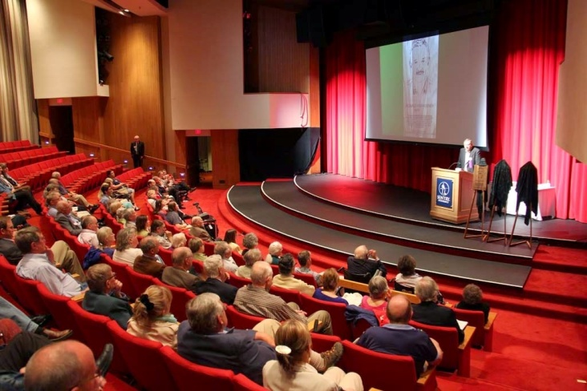

**WCHF 2015 Induction Ceremony** *Photo by J. Passineau*

**Short Biographies**

**(see pages 3-5 for photos and longer bios)**

**1. Roy (1929-2016) and Charlotte (1944- ) Lukes**

Door County naturalists, Roy and Charlotte Lukes, spent their lifetimes protecting the natural beauty of the peninsula and sharing its magic through their teachings, writings, and personal charm. As “Partners in Nature,” they build the Ridges Sanctuary into a center for conservation education, research, and advocacy. They educated and inspired citizens of Door County and the State through their many research efforts, lectures and nature walks, books and newspaper columns.

They were also instrumental in protecting many of the county’s most scenic gems and ecologically valuable habitats. Roy and Charlotte saw their scientific research on the flora and fauna of Door County as a cornerstone to their work in conservation related education, policy and public leadership. In recognition of their lifelong collaboration, the couple received nearly thirty awards from numerous educational, literary, civic and environmental organizations.

**2. George Meyer (1947 - )**

A highly respected and influential Secretary of the Wisconsin Department of Natural Resources, George Meyer was instrumental in creating and advancing major conservation and environmental policies affecting all of the State’s natural resources. During his three decade career with the DNR, Meyer worked on many of the most challenging, and often controversial, policy issues affecting Wisconsin.

In addition to his years in public service, Meyer spent much of his life promoting citizen participation and the advancement of conservation organizations. Since retiring from the DNR in 2002, Meyer has led the

Wisconsin Wildlife Federation, serving as its first

Executive Director. With 200 affiliate organizations statewide, the Federation promotes sound resource management through its educational and advocacy programs. Throughout his career, he has been respected for his integrity, leadership, and unassuming personality.

He has received many awards and much recognition for his contributions to conservation.

**3. Arlie (Bill) Schorger (1884 - 1972)**

As a man of many talents, Arlie (Bill) Schorger excelled as a chemist, inventor, businessman, and wildlife conservationist. In conservation circles he is most well known forhis work as a nature historian and for his books on the life histories of Wisconsin’s Wildlife and man’s impact on them. His 1955 award winning book*, The Passenger Pigeon: Its Natural History and Extinction* helped advance a global concern for wildlife management, biodiversity and the new field of conservation biology.

He became a Professor of Wildlife Management after retiring from his business career in paper chemistry and devoted the rest of his productive life to advancing conservation through his research and writings. As a personal friend of Aldo Leopold, he also played a pivotal role in launching Leopold’s career and conservation legacy.

He was also known for his public service, philanthropy, and leadership in state and national conservation organizations. He served on the Wisconsin State Conservation Commission (now the Wisconsin DNR Board) and as President of the Wisconsin Academy of Science, Art and Letters. As a philanthropist, he contributed to many conservation, literary and civic programs.

**_______________________________________**

**Quotes by WCHF President**

Reflecting on this year’s ceremony,

WCHF President, Joe Passineau, said:

“The Inductees this year show us that - *Conservation depends on the Big C’s of Cooperation, Collaboration and Commitment!* And that advancing conservation has no age limit! Fascinated with nature as youths, they all worked well into their senior years to share their love for the Earth*.”*

“As ‘Partners in Nature’, Roy and Charlotte Lukes’ love for each other and for nature blossomed into a lifelong Conservation Legacy in Door County. George Meyer spent a lifetime working with friends, organizations and state agencies to promote conservation through his personal commitment and dedication. Arlie Schorger, made his mark in the annals of Wildlife Conservation by collaborating with fellow scholars, researchers, and conservation organizations. He also showed that philanthropy and financial contributions are essential to the advancement of conservation!”

Passineau added: “With the addition of our four new inductees, the Wisconsin Conservation Hall of Fame now recognizes 96 men and women who have dedicated their lives to the advancement of Wisconsin’s Conservation Legacy. Through their personal and professional efforts, dedication, and love for nature, they have changed the world. If you know of others deserving recognition, send nominations to the WCHF.”

**The Wisconsin Conservation Hall of Fame**

The Wisconsin Conservation Hall of Fame and Visitor Center is located at Schmeeckle Reserve in Stevens Point. It was established in 1985 to advance the conservation legacy of Wisconsin and now recognizes 96 leaders who have contributed significantly to it.

Individuals may be nominated for induction by member organizations or by the public. Based on a set of criteria, nominees are selected for induction by the WCHF Board of Directors and an independent Board of Governors.

The WCHF and Schmeeckle Visitor Center includes:

(a) a sunlit gallery displaying recognition plaques of the inductees, (b) a meeting/classroom used free of charge by hundreds of civic organizations each year, and (c) an interpretive display museum illustrating the full story of conservation in Wisconsin. Each year thousands of visitors also enjoy the beautiful landscapes, hiking trails, educational programs and gift shop at Schmeeckle Reserve.

WCHF is a cooperative venture of 31 state-wide conservation organizations. WCHF depends on the generous support of member organizations, affiliate members, grants and donations.

For membership information use: [www.wchf.org](http://www.wchf.org) . Or to join, see the on-line Eventbrite Ticket option: [http://bit.ly/WCHF2018Registration](https://urldefense.proofpoint.com/v2/url?u=http-3A__bit.ly_WCHF2018Registration&d=DwMFAg&c=-cNKEo6N5UU7B9VDGD_3Mw&r=zdWMWtdjearADaw_6UW6mYxqiAxdkw6Onig3xjcdHxQ&m=TRyItYGdrncwMvUn-eu9smnaWRSt7MS-1TccnldaViU&s=cfInm3vLGuyIEyEyUqbDwJvTIzBFoVzGhTKZ1vUxL_s&e=)

***Longer Biographies***

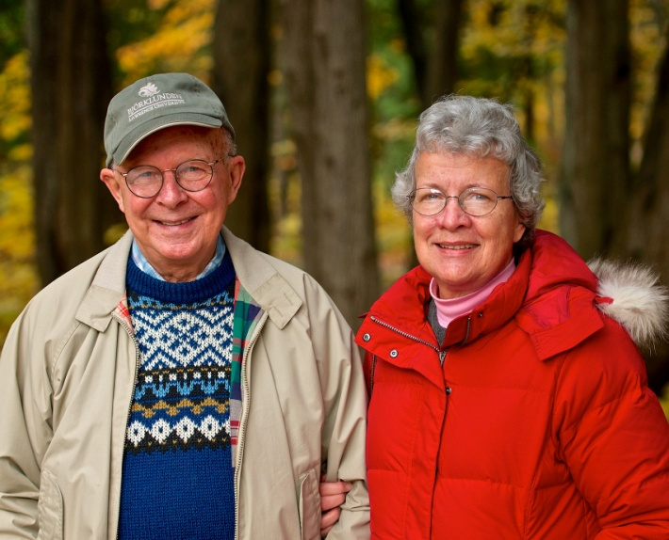

***Photo Credit: Len Villano Photography***

**Roy (1929 – 2016) and Charlotte (1944- ) Lukes**

Door County naturalists, Roy and Charlotte Lukes, spent their lifetimes protecting the natural beauty of the peninsula and sharing its magic through their teachings, writings, and personal charm. As “Partners in Nature” they built the Ridges Sanctuary into a center for conservation education, research, and advocacy. They educated and inspired citizens of Door County and the State through their many research efforts, lectures and nature walks, books and newspaper columns.

They also fought for Wisconsin conservation policy and funding for the protection of Door County’s natural areas and wetlands such as Toft Point Wilderness, Newport State Park, Whitefish Dunes, Mink River Estuary, and Moonlight Bay. The region is now recognized as a Ramsar Treaty ”Wetland of International Importance.”

As leaders in the field of conservation and environmental education, Roy and Charlotte taught classes and led hikes at the Ridges Sanctuary, the Clearing in Ellison Bay, Lawrence University, and other venues. As a renowned nature writer, naturalist, photographer, teacher and newspaper columnist, Roy inspired millions**.** His numerous newspaper articles and five books on nature, including *Once Around the Sun: A Door County Journal*, capture the seasonal joys of time spent outdoors. He was renowned for his gentle smile, encyclopedic knowledge, and his story-telling ability, which could enthrall both children and adults.

Charlotte, too, excelled as a naturalist, teacher and writer. In addition to her scientific work and publications on the Mushrooms of Door County, she continues to teach classes, present programs, and lead nature hikes

throughout the region. Spanning five decades, Roy and Charlotte wrote over 3000 newspaper columns for local papers.

Roy and Charlotte saw scientific research and the study of the natural world as a cornerstone to their work in conservation related education, policy and public leadership. Roy led much of the research effort at the Ridges focusing on its flora and fauna. He was an expert on the area’s orchids and birdlife. Charlotte’s research on the mushrooms of Door County, including the identification of over 600 species, has contributed to newspaper articles, publications, and the UW-GB Center for Biodiversity. They also promoted “citizen science” by getting volunteers involved in projects such as Audubon Bird Count and WSO’s Wisconsin Bird Atlas.

In recognition of their lifelong collaboration, the couple received nearly thirty awards from numerous educational, literary, civic and environmental organizations. They jointly received the Lifetime Achievement Award from Gathering Waters Conservancy, multiple awards from the Wisconsin Society of Ornithology, the Nature Conservancy, and UW-Green Bay Center for Biodiversity.

To learn more about Roy and Charlotte Lukes, see Myles Danhausen’s excellent article *Nature Boy: The Life and Times of Roy Lukes* in the Summer 2016 issue of Wisconsin People and Ideas: [*https://www.wisconsinacademy.org/magazine/summer-2016/profile/nature-boy*](https://www.wisconsinacademy.org/magazine/summer-2016/profile/nature-boy)

***Longer Biographies***

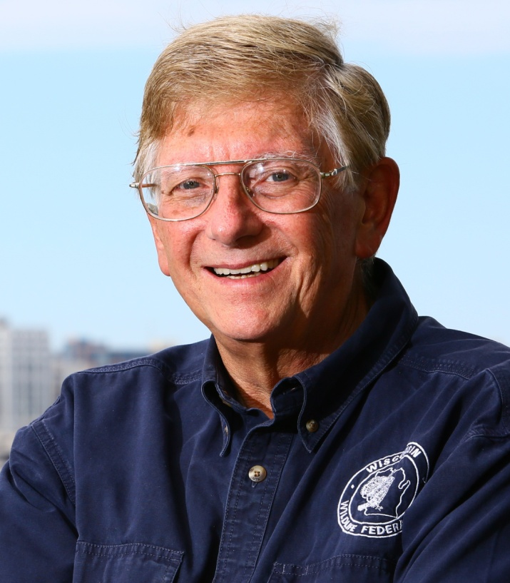

***Photo Credit: Milwaukee Journal/Sentinel***

**George Meyer (1947 - )**

A highly respected and influential Secretary of the Wisconsin Department of Natural Resources, George Meyer was instrumental in creating and advancing major conservation and environmental policies affecting all of Wisconsin’s natural resources.

His appreciation and respect for the land and its resources began as a youth while growing up on the family farm in New Holstein, Wisconsin. After receiving his B.A. degree in Economics from St. Norbert College and his Law degreefrom UW-Madison in 1972, he joined the Wisconsin DNR and eventually advanced to the agency’s top leadership position.

As Staff Attorney (1972 - 1980), Enforcement Division Administrator (1980 - 1993), and as Secretary of the DNR (1993-2002), Meyer worked on many of the most challenging, and often controversial, policy issues affecting the State including: wildlife management, hunting regulations, and chronic wasting disease; parks and outdoor recreation; land use and urban planning; air and water quality; wetland and shoreline protection; urban and agricultural run-off; clean-up and re-development of toxically contaminated lands; and the negotiation and implementation of Treaty Rights held by Wisconsin’s Ojibwe Tribes. During his 30 year career with the DNR, he often served as the agency’s chief spokesperson with the media and at public, court, and legislative hearings. He was respected by all he worked with for his calm demeanor, knowledge of the issues, science-based viewpoint and judgment.

After retiring from the DNR in 2002, Meyer has continued to advance conservation by serving as the first Executive Director of the Wisconsin Wildlife Federation, a citizen conservation organization promoting sound resource management through the educational and advocacy programs of 200 affiliated conservation clubs. With his organizing abilities and persuasive talents, he continues to mobilize citizens to fight for Wisconsin’s Conservation Legacy. He has also championed WWF’s conservation education initiatives including its partnership with the Wisconsin Green School Network, the rescue and revitalization of the MacKenzie Education Center in Poynette, and the creation of the Wisconsin Conservation Leadership Corps (CLC), focusing on college and high school students, to assist in the development of future conservation leaders.

For his leadership and contributions to conservation, he has received many awards and recognitions. He was appointed a Visiting Professor at Lawrence University from 2002 to 2004 teaching courses in environmental policy and law; served in leadership roles in the Association of Fish and Wildlife Agencies and the Environmental Council of the States; and serves as a member of the WCHF Board of Governors.

To learn more about George Meyer and the Wisconsin Wildlife Federation, go to the WWF Website: [*http://www.wiwf.org/*](http://www.wiwf.org/)

***Longer Biographies***

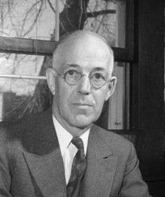

***Photo Credit: Wisconsin Historical Society***

**Arlie (Bill) Schorger (1884 - 1972)**

As a man of many talents, insatiable curiosity, and boundless energy, Arlie Schorger excelled in multiple careers: as a chemist, inventor, businessman and wildlife conservationist. His career in chemistry, focusing on cellulose and wood, resulted in 41 patents, that enriched him and his companies, and fueled his philanthropic interests in conservation.

In conservation circles, he is most well known for his work as a nature historian and for his life histories of Wisconsin’s wildlife and man’s impact on them. His 1955 award winning book*, The Passenger Pigeon: Its Natural History and Extinction* and his 1966 book, *The Wild Turkey: Its History and Domestication,* are classics and helped advance a global concern for wildlife management, biodiversity and the new field of conservation biology.

As a founder of the Wisconsin Society for Ornithology, he played a leading role in telling the story of the Passenger Pigeon and wrote the famous inscription for the 1947 Passenger Pigeon Monument at Wyalusing State Park, the first monument dedicated to the demise of an extinct species.

Schorger had a lifelong interest in nature since his childhood in Ohio, and pursued his interest in wildlife research and writing for most of his adult life. After retiring from a long career in chemistry and business, he was able to focus full time on his avocation. In 1951 he became a Professor of Wildlife Management at UW-Madison and devoted the rest of his life, until age 87, to his research and writing on wildlife and conservation.

In addition to his major books, he was a prolific author of over 250 journal articles, book chapters, and reports and kept a lifelong journal of natural history observations and insights. Working in an era before copy machines and computers, he was renowned for his encyclopedic memory, and his ability to sift through, hand copy, digest, and synthesize mountains of obscure facts, reports and books to extract insights, patterns and new understandings about wildlife. In this way he mirrored the talents of other famous naturalists and environmentalists, such as Rachel Carson, whose book, *Silent Spring,* on the impacts of DDT/Pesticides launched the Environmental Movement.

A little known fact is that Schorger also helped launch the wildlife career and Conservation Legacy of Aldo Leopold. When Leopold left the USDA Forest Service to pursue his new career as a wildlife consultant, Schorger helped persuaded the University to hire Leopold, an up-and-coming wildlife conservationist, to a faculty position in 1933, and again in 1938 to retain Leopold by offering to create the world’s first academic department devoted to the new field of wildlife management. Without Bill Schorger and his friends, Wisconsin’s tie to the Leopold Conservation Legacy may have slipped away.

He was also known for his public service, philanthropy, and leadership in key conservation organizations such as the Wisconsin Society for Ornithology (co-founder), the American Ornithologist’s Union and the National Audubon Society. He served on the Wisconsin State Conservation Commission (now the Wisconsin DNR Board) and as President of the Wisconsin Academy of Science, Art and Letters.

Using his patent royalties and business investments, he contributed to many conservation, literary and civic programs. A lover of books, he donated his extensive personal library to the University and its Wildlife Department. He received many honors for his achievements and contributions from a variety of conservation organizations, civic groups and universities.

To learn more about Arlie Schorger and his contributions to conservation, see Dr. Stanley Temple’s excellent article *A Passion for a Pigeon* in the Summer 2015 issue of Living Bird: [*https://www.allaboutbirds.org/a-passion-for-a-pigeon/*](https://www.allaboutbirds.org/a-passion-for-a-pigeon/)

***END OF WCHF 2018 NEWS RELEASE***

**Contact** [**jpassine@uwsp.edu**](mailto:jpassine@uwsp.edu) **for digital photos of inductees.**